Plot of detection*count. Legend: A = 1 obs, B = 2 obs, etc.
detection |
39600 + N
| Y
|
| C
36300 + A
| A
| C
| D
33000 + B
| C
|
|
29700 +
|
|
|
26400 +
|
|
| A
23100 + B
| ADB
|
| C
19800 + AXZZ A C
| AFZZCJ B K
| ABQO EC A
| DFFHFC AFB B
16500 + DCIBCJE BB AB
| ITICACFK A ABBDS B
| HNUA BBAJDA BAA CB
| DGBJFAJHKGAA BD A B
13200 + FZIGBBBBB A BA A A DG
| QYZH ABACFOSA A A EG
| KQDAJHHA ABZZVKA A BB LQ
| AEGAAB A ACAJDKC A A AA BI A A
9900 + ZZB H GDBAA JZ PR HA IC
| BKZDA BDEBPZYZZR C HD JB
| GKEA CBABFB BD AA BA HD A
| BGOCAAAIAGNJ H ICAIJFB BLFA EO B
6600 + XQKZBBCFH A B EHHHBB A A V
| KZG BB BEGD FJAEBPPDPB ND M H Z
| HKZ BDKDGHBFQVFZOHS HI CA BDBAX CABCCBBZ B
| DYXIKJDD DCFABZOGKZ JHABB AC LK AV A
3300 + JZZGCOA AA BJXHZZZXHCC IC A C A BCL A
| DZZZMFWHIJ HJVLVZZZIAEFCBBKC A BAB GAHB A CB
| LZZZKDK P KE IIA B B DBBD A AH CU
| QZZZZZNMKZUGC ABBAEBBDDC CBA I A D B A A O B
0 +ZZZZZIYPAB AKACA AMZDZRBAA AAR EACPPH H AAB BA BH A AAC
-+---------+---------+---------+---------+---------+---------+---------+---------+---------+---------+---------+---------+
0 3320 6640 9960 13280 16600 19920 23240 26560 29880 33200 36520 39840
count
NOTE: 3249 obs hidden.

Number of Observations Read | 7449
Number of Observations Used | 7449

Analysis of Variance
Source | DF | Sum of  Squares | Mean  Square | F Value | Pr > F
Model | 1 | 2.23553E11 | 2.23553E11 | 18625.9 | <.0001
Error | 7447 | 89380671846 | 12002239
Corrected Total | 7448 | 3.129337E11

Root MSE | 3464.42473 | R-Square | 0.7144
Dependent Mean | 5079.16942 | Adj R-Sq | 0.7143
Coeff Var | 68.20849

Parameter Estimates
Variable | DF | Parameter  Estimate | Standard  Error | t Value | Pr > |t|
Intercept | 1 | -320.68432 | 56.36247 | -5.69 | <.0001
count | 1 | 0.69801 | 0.00511 | 136.48 | <.0001

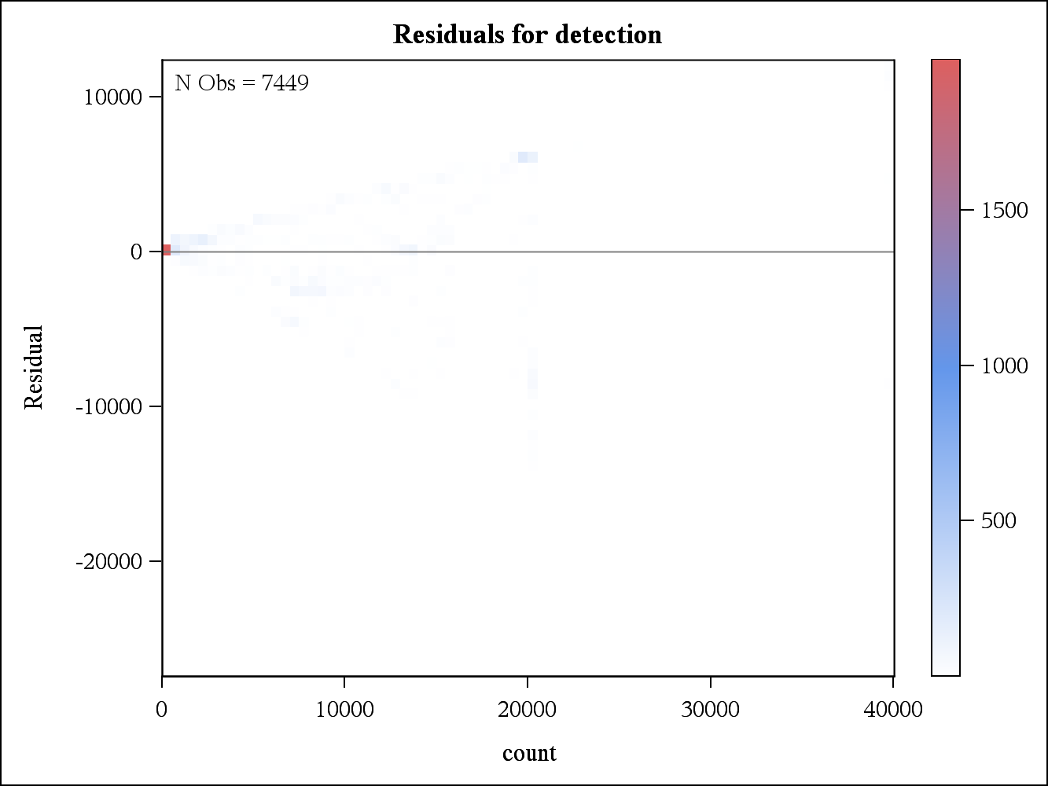

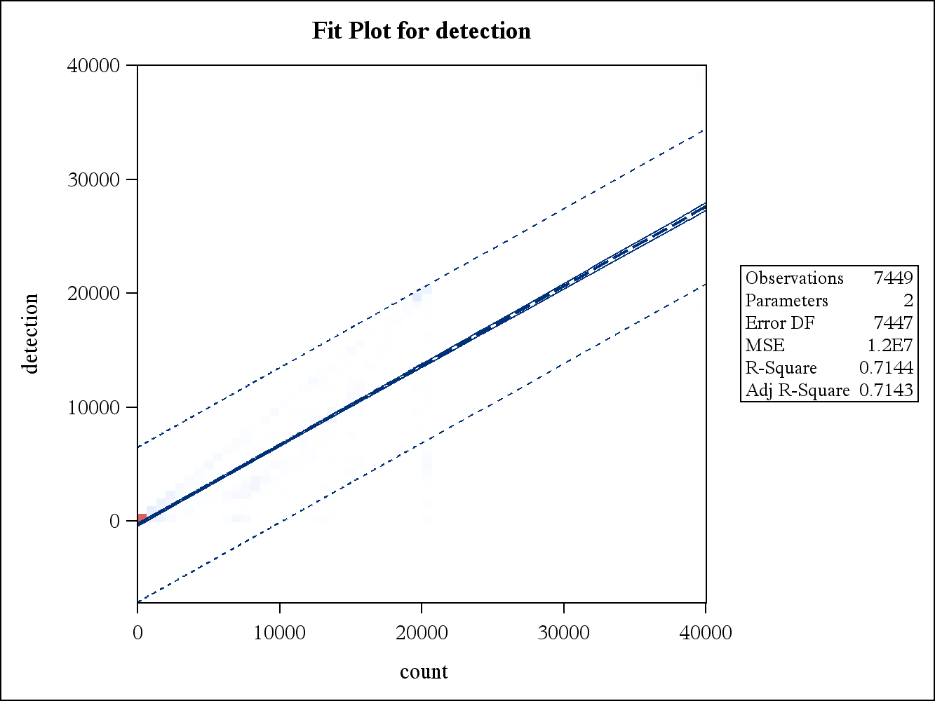
2 Variables: | count detection

Simple Statistics
Variable | N | Mean | Std Dev | Sum | Minimum | Maximum
count | 7449 | 7736 | 7849 | 57626094 | 0 | 40000
detection | 7449 | 5079 | 6482 | 37834733 | 0 | 39996

Pearson Correlation Coefficients, N = 7449
Prob > |r| under H0: Rho=0
 | count | detection
count | 1.00000 | 0.84521  <.0001
detection | 0.84521  <.0001 | 1.00000

